**CS212: Theory of Automata**

**Assignment No 2**

**Spring 2024**

**Instructions (Ignoring Instructions will lead to zero marks)**

**1. Due Date: Tuesday, 11th June 2024 (11:59 pm), Submit it on CMS only (no emails). CMS will not accept assignment after the deadline, and will automatically be blocked. No assignment will be accepted after deadline.**

**2. Submit your assignment in PDF format only. No handwritten assignment will be accepted.**

**3. Copy from any other student will lead to zero marks in the entire assignment for both the students.**

**4. Title page (first page) should only contain student name, roll number , Semester class and assignment number.**

Q1. Convert the following FA Machine into equivalent Regular Expression using Kleene’s Method. Specify each step clearly.

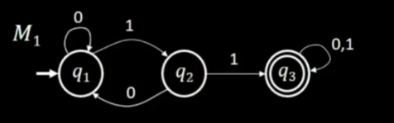

Q2.Using the technique discussed by Martin , Build an FA that accept the following language.

L={w belong to {a,b}*: Length(w) >=2 and second letter of w, from right is a}.

Q3. Build an FA for the following regular Language L defined over ∑= {a,b}

L= {a, ab, bab, bb}

Q4. Give the 5-tuple representation and draw the transition table for the following FA.

